Question B3
Name
Institution
Date

Question B3
Contemporary studies have proved that growth theories have gained relentless relevance to the growth and stability of the global economy. Notably, the theories give relentless emphasis to the importance of knowledge, technology, entrepreneurship, and innovation while disregarding the primitive assertion by the majority that external and intense forces rule out economic growth and stability (Gabarro & Serna, 2017). Every independent economy is mandated to bolster its performance in all avenues. Governments should actively steer away from reliance upon consumption to create spaces for economic diversification and expansion of other sources of aggregate demand. These include ensuring economically promising government expenditures, net exports, and private investments as well. In other words, every government must strive to maintain the balance of core components of economic growth, and hence the government of UK is not exceptional. Although it is always easier to recommend than to implement changes, UK needs to enact reliable policies that could firmly act against any fundamental shake-up of her economy. Based on the IS/MP framework, both monetary policy and fiscal policy greatly affect the short-run impact on real national income of a negative demand shock.
Monetary policy is always exogenous, a key tool used to control inflation and boost economic growth. Concerning the IS/MP model, the money supply sets the position of the MP curve and has no impact on the IS curve. The policy is set by the central bank based on how it responds to the changes in output (Gabarro & Serna, 2017). The relationship is as shown below:
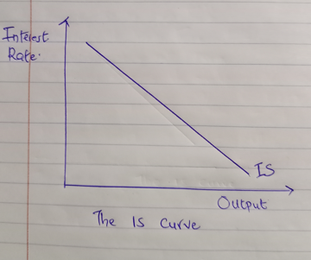
Fig 1
On the other hand, the MP curve takes position when the central bank raises the real interest rate with an increase in output, giving an upward linkage amid interest rate and output, as shown in the figure below.
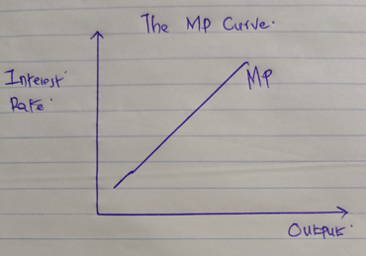
Fig 2
The ideal difference between IS and MP curves stems from policymaker’s goals for output and inflation. However, when output decreases, the central bank tends to contrast the interest rates to boost demand for goods (Alavi, Moshiri, & Sattarifar, 2016). Analytically, it is quite unusual for the central banks to keep altering the interest rates to fix demands for goods all the time. Central banks are mandated to take initiatives so that the ideal output is within the usual capacities while preventing too much inflation. The ultimate relationship between output and inflation rates makes the central bank hike the real interest rates as an increasing function of output.
Through monetary policy, the central bank makes an effort to fully control inflation’s short-run impact on real national income of a negative demand shock. The central bank makes well-thought-out changes in the money supply to help arrive at the projected interest rates. Notably, skyrocketing inflation levels convince the central bank to consider heightened levels of interest, which makes the MP curve shift up, a clear indication of the linkage amid the real output and interest rate at a given time. Also, changes in inflation hold a critical role in this interaction because it makes the MP curve shift over time. For example, during the covid-19 global pandemic, most UK sectors encountered a negative demand shock. Investors were not interested in taking a position in many fields due to the strict social distancing rules. To ensure quick economic recovery, the England Central Bank altered interest rates from 0.50% in March 2020 to 0.10% in May 2021, a good rate for borrowers during this period of economic recovery (UK Housing Statistics & Trends, 2021).
During short-run economic fluctuation, the IS-MP model is commonly used to define the economy's real interest rate and output. Borrowing from the Keynesian cross, a point where the two curves intersect indicates the point of planned expenditure and the estimated output at that point. Hence, the central bank can accurately establish interest rates as per its policy rules in the short run. The figure below illustrates the IS-MP model.
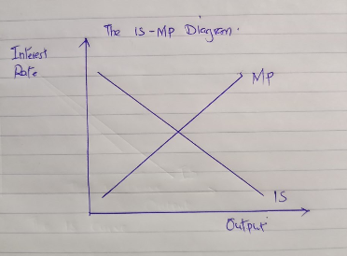
Fig 3
When the central bank adopts a more stringent monetary policy by adopting higher levels of real interest rates at a certain output level, the MP curve shifts upward with no impact on the IS curve. In this regard, it is worthy to assert that an increase in real interest rate adversely impacts investment, reducing disposable income and hence contrasting the real national income.
Changes in fiscal policy also affect the short-run impact on real national income of a negative demand shock. For instance, when the government diversifies its expenditures, there is a direct increase in planned expenditure, affecting the IS curve.

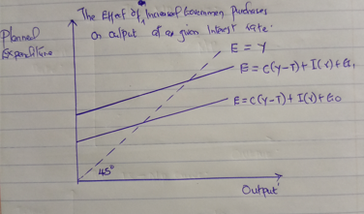
Fig 4
Analytically, the area of intersection between the planned expenditure and the 45-degree line indicates equilibrium output at a given real interest rate defined by the point of intersection on the IS curve. The actual interpretation is that increased government spending leads to an escalation in planned expenditure within a given income level, as shown by the upward shift of the planned expenditure curve in the above figure. There is an increase in the equilibrium level of income.
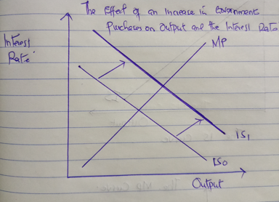
Fig 5
The IS-MP diagram shows that the level of equilibrium income tends to increase with the IS curve shifting to the right at a given interest rate (Wei & Han, 2021). The central bank is likely to maintain output constant and treat interest rate as a function. The MP curve is not affected. The point of intersection between the IS curve and the MP curve shows a new equilibrium point with increased output and interest rates.
Herein, one can conclude that raising government spending positively impacts the interest rate and output in the short run. An increase in planned government expenditure in the UK had led to increases people’s disposable income, hence raising consumption (Wei & Han, 2021). Such a practice can be used to control undesired negative demand shock as the economy edges recovery. Both rich and developing countries should never hesitate to borrow the effectiveness of IS-MP model during this challenging status of global economy. As such, they should establish considerable economic responses to the global pandemic, ramping up spending, while using monetary policy to address blow of lockdowns among other measures that had been imposed.

References
Alavi, S. E., Moshiri, S., & Sattarifar, M. (2016). An Analysis of the efficiency of the monetary and fiscal policies in Iran economy using IS–MP–AS model. Procedia Economics and Finance, 36, 522-531.
Gabarro, J., & Serna, M. (2017). Uncertainty in basic short-term macroeconomic models with angel-daemon games. International Journal of Data Analysis Techniques and Strategies, 9(4), 314-330.
UK Housing Statistics & Trends (2021). UK Interest Rate History / Graph & Facts. Retrieved from https://www.propertyinvestmentproject.co.uk/property-statistics/uk-interest-rate-history-graph/
Wei, X., & Han, L. (2021). The impact of COVID-19 pandemic on transmission of monetary policy to financial markets. International Review of Financial Analysis, 74, 101705.

